TABLE OF CONTENTS

- PROBLEM STATEMENT -------------------------------------------------------------------- 1
- PROPOSED SOLUTION --------------------------------------------------------------------- 2
- PROJECT DESCRIPTION ------------------------------------------------------------------- 3
- COMPONENTS -------------------------------------------------------------------------------- 4
- METHODOLOGY ----------------------------------------------------------------------------- 5
- CIRCUIT DIAGRAM ------------------------------------------------------------------------- 6
- EXPECTED RESULTS ----------------------------------------------------------------------- 7
- PRACTICAL APPLICATION --------------------------------------------------------------- 8
- REFERENCES --------------------------------------------------------------------------------- 9

PROBLEM STATEMENT

A traditional multi-wire cable tester relies on a single wire to test multiple wires, leading to inaccurate results. The existing testers often fail to detect faults in parallel-wired systems, resulting in potential safety hazards and costly repairs. Additionally, the existing testers require manual testing and are prone to human error, which can lead to incorrect diagnoses.

1
PROPOSED SOLUTION

In order to address the problems mentioned in the problem statement, we are going to develop a novel Multi-Wire Cable Tester circuit design that utilizes a unique sensing mechanism to detect faults in multi-wire cable systems. This circuit features a compact and user-friendly design that allows for easy testing of multiple wires simultaneously. The tester can accurately detect faults and provide clear diagnostic results, reducing the risk of safety hazards and costly repairs.

2
PROJECT DESCRIPTION

Cable Tester is the device by which we can check whether the cable has defected or it is connected in a proper way. A cable tester is the very useful way to determine the physical quality or connectivity of the cable or wires individually while installing them. It detects whether the cable is connected properly and the communicative strength between the ends of the cable

3
COMPONENTS:

- 555 Timer IC
- 4017 IC
- Resistors (10k-1, 2.2 k-2,500 k-4,)
- Capacitors (10uf-1,10nf-1)
- Red LED
- 9V supply
- Jumper Wires
- Bread Board

4
METHODOLOGY
- 555 Timer IC: Generates a continuous clock pulse to drive the 4017 IC.
- 4017 IC: A decade counter that sequentially activates its output pins based on the clock pulse from the 555 Timer.
- Resistors (10kΩ, 2.2kΩ, 500kΩ): Control current flow, set timing intervals, and limit current to LEDs.
- Capacitors (10μF, 10nF): Stabilize the timing circuit and filter noise in the 555 Timer.
- Red LED: Visually indicates the status of each wire in the multi-wire cable by lighting up.
- 9V Power Supply: Powers the entire circuit, providing the necessary voltage for the components.
- Jumper Wires: Used for connecting components on the breadboard.
- Breadboard: A tool for prototyping and assembling the circuit without soldering.

5
CIRCUIT DIAGRAM:

The labelled diagram for driving a SCHMITT TRIGGER CIRCUIT Figure 1.
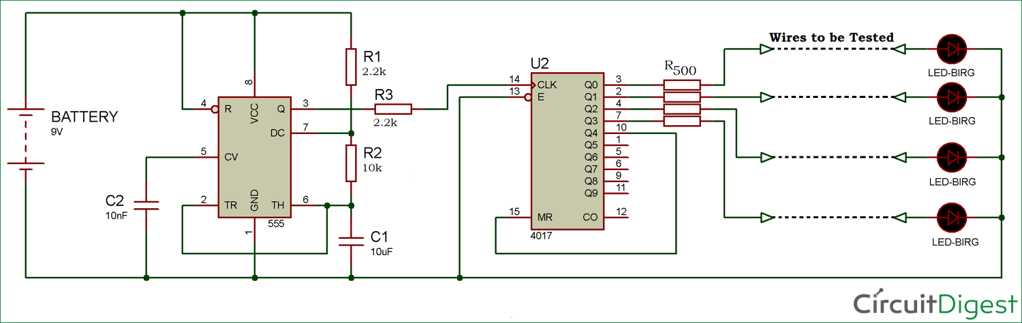
Figure 1

6
EXPECTED RESULTS:

The expected result of the Multi-Wire Cable Tester project is that, once powered on, the 555 Timer IC will generate a continuous clock pulse that drives the 4017 Decade Counter IC. The 4017 IC will sequentially activate its output pins, lighting up the connected Red LEDs in a specific order (Q0 to Q9), providing a visual indication of each wire in the multi-wire cable. When a wire is properly connected, the corresponding LED will light up, confirming the wire's continuity. If a wire is missing, broken, or disconnected, the corresponding LED will remain off, highlighting the fault. This process allows for easy identification of any issues in the multi-wire cable, ensuring a simple and effective testing method.

7

PRACTICAL APPLICATIONS

- Network Cable Testing (Ethernet Cables): Verifies the integrity and correct wiring of Ethernet cables to ensure proper network connectivity.
- Telecommunication Cables: Checks the continuity and correct wiring of telecommunication cables for reliable phone and data transmission.
- Automotive Wiring: Tests the multi-wire cables in vehicles to ensure proper connections for sensors, lights, and electrical systems.
- Home/Office Wiring: Helps troubleshoot and verify the integrity of multi-wire cables used in home or office electrical setups.
- Industrial Wiring: Ensures the proper functioning and continuity of multi-wire cables used in industrial machinery and control systems.

8
REFERENCES

[1] Aspect, “Multi-wire-cable-tester ”2024. [Online], Available:
https://circuitdigest.com/electronic-circuits/multi-wire-cable-tester
[Accessed on 04-March-2025]

9

